**Project Databases**

## Project Plan

**Team Amadeus:**

Shamil (523001)

Abraham(557797)

Sasmita(552301)

Le(559942)

Yog(532407)

**Table of Content**

* Functionality

- Functional Requirements

- Technical Requirements

* Conceptual Data Model
* Data Model
* Project Assignment

- Project goals and required

- Product Assignment

* Division of Responsiblities
* Work Division

# Functionality

While the information analysis focused on the data to be stored, some information about functional and technical requirements were already discovered. These findings are mentioned here.

## Functional requirements

The client requests a system which makes it possible to offer courses by an online registration system. The courses can be manufactured and removed by a few specific employees of the school, while they are administrator. The available courses can be taken only once, but it is possible for the administrator to modify the system so the student can take a course another time, in case it failed the first time. Every course has a limit of students; this limit is determined by the administrator. The course contains a number of lessons which take place at variable times and locations. Every course is an optional subject in a certain field of study, which can be lectured by internal or external employees.

## Technical requirements

While it is not allowed to connect to the system and the network of Inholland, employees need to register the students manually in the system.

An export function must be available, to provide the administrator with information of the courses and students.

After registration students must receive a confirmation by email.

Students log in with their Inholland email address.

The system can be opened and closed, based on a timer function.

A taken course stays available for the administrator, which can change it and publish it again.

Source: project description

# Conceptual Data Model

## Data model

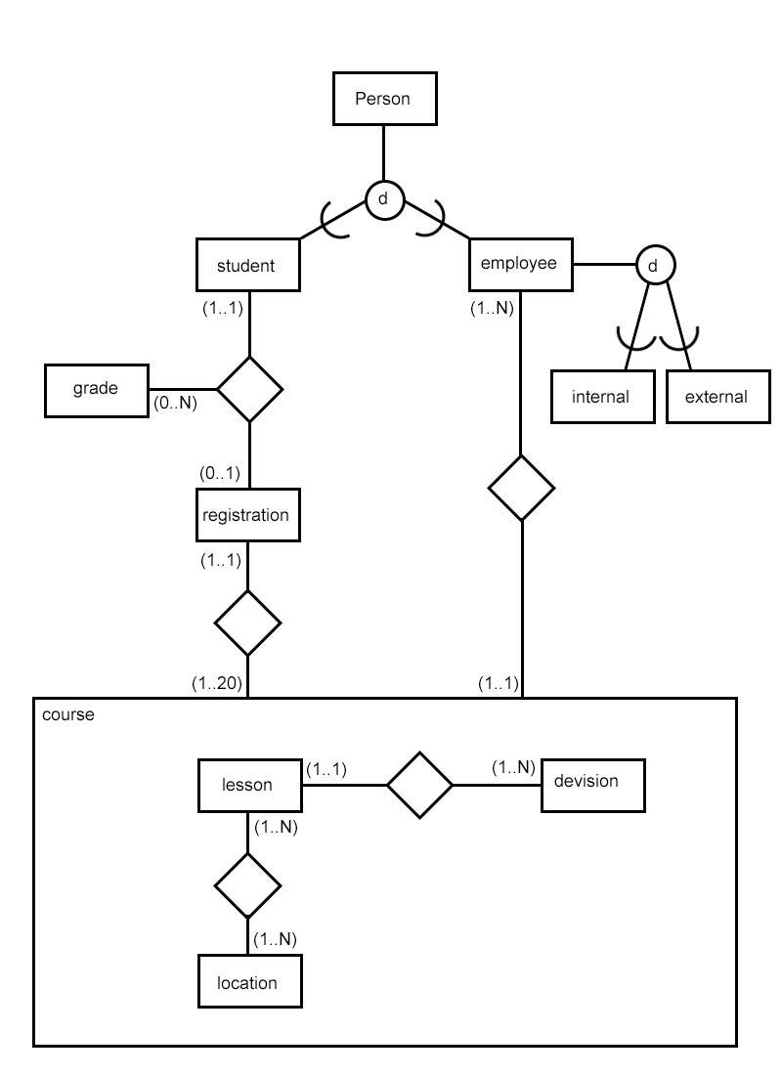

Source: Project description

Project assignment

1. **Project goals and required / expected milestones and results (products);**

A project has two purposes: developing competencies which cannot be trained in more constrained modules (Manage, Research, Professionalize) and integrating the other competencies in one case study (the five other competencies.) Therefore, the eductional purpose of this project is twofold:

* Integrating the courses from this year into a real-life case, allowing students to experience the cohesion and interdependency between them. This will be achieved by answering the research question by building an application suiting the purpose of the client.
* Learning to apply one specific phase of the research cycle, in this case the phase 'Context and problem analysis.' This will be achieved by specifically having to research the underlying question, interviewing the client once, and figuring out what's already known about the problem.

The competencies are developed in the following learning objectives. After successfully finishing this project, the student can:

* Work in a team to provide a solution to a customer (8.1.5)
* Use methods in applied research to solve a practical problem and prove the solution to be correct (7.x)
* Create and work with a project plan, using a prestructured research and development structure (5.1.2)
* Analyse the needs of the client and translate the results of this analysis to a web-based application (1.1.3)
* Design this web application using prescribed methods and technologies (2.1.3)
* Implement the design including the database, using prescribed methods and techniques (3.1.2)
* Use a version control system to coordinate the work within the team (4.1.1)
* Create and maintain basic functional and technical documentation for the application (4.1.2)
* Present the solution to the client, both written and orally (6.2.3)
* Receive feedback on the results of work and improve by reflecting on this feedback (8.1.2)

**Source: project description**

1. **Products Assessment**

Questions by the project group:

1.What type of user interface you would like to interact with?  
  
2.Does the instructor has to log in to the system or it's solely based on interaction with students?  
  
3. Shall we add a list of courses or they are already in the database ?  
  
4. Are we using the existing student database or the list is on paper?  
  
5. Can we schedule a test session with IBIS students ?

Answers by the client:

1.       This is a tech question I think... I have no idea. What types of interface are there that I could choose from?  
2.       Our administrators have to be able to log in to the system to put the courses, dates and time in it and to retrieve the registration data after registration has closed. Other staff members do not need to go into the system.  
3.       We have a list of courses we are offering right now, but the list changes every term. So we need to be able to add (and remove) courses to the system/database at all times. I can provide the list of the current courses that I showed this morning, for you to use in the testing phase. You can find the list in the attachment.  
4.       It would be preferable to use the existing student database.  
5.       I'm sure we could. I'll arrange for a few students in due time.

**Additional Questions:**

Student  
1. is the student using inholland email account or his private email?

Employee  
2. What is the difference between the address, residence and postal code?

Course  
3. Could you explain the cost attribute? what value will be in the cost attribute?

Lesson  
4. Is it correct if we assume that a lesson is a single class from a particular course?  
in this way we mean that 1 course might have 3 lesson. if so, can a couple of lesson from the same course have different capacity?

Division  
5. It is written that the division is a education group.  
we understand that courses are grouped by division, is this correct?

Location  
6.Could you give example of logical place that you mentioned in the document?  
we understand that the physical place would be the room number.

7. what is the meaning of attribute range??

**Answers:**

1. Inholland account
2. Why would this information be relevant for the app? I don't recall putting this is the brief.
3. This app will save us money in terms of saving us a lot of time. Now it takes about a week of 1 person's work each time we have a registration (3 times a year)... That's about EUR2500 I'd think.
4. A lesson is a contact moment between the course teacher and the students. A course may have several lessons. At any moment in time, a course only has 1 group of students participating. The capacity (in terms of number of students is for the course as a whole, so for each lesson in the course.
5. I think so... I didn't write anything about divisions I think. Maybe check this with Harald too, to make sure.
6. A room number would be 'E1.12' or 'A2.24' for example. It can also be 'other', if the course is conducted somewhere else than in out own building.  
     
   7. I have no idea... Sounds like tech talk - ask Harald, I think he wrote it.

**Division of Responsibilities:**

|  |  |
| --- | --- |
| Shamil | team leader |
| Sasmita | archivist |
| Abraham | database modeller |
| Le | website developer |
| Yog | database modeller, PHP developer |

Work Division on PHP part

|  |  |  |
| --- | --- | --- |
| Schedule week | Work Description | Person Responsible |
| 4 | Design of front end web pages and generating frontend webpages | Le |
| 4 | Generating frontend webpages | Sasmita |
| 5 | Webpage Optimization | Shamil |

**Work Division**

|  |  |  |  |
| --- | --- | --- | --- |
| **Schedule week:** | **Work description** | **Person Responsible** | **Signature** |
| **Week 1** | Project Plan | Shamil |  |
| **Week 2** | Interview with client | Le |  |
| **Week 3** | Setting up GIT  Creating first database version  Start creating code | Sasmita |  |
| **Week 4** | Creating database structure | Abraham |  |
| **Week 5** | Creating final database structure | Yog |  |
| **Week 6** | Optimizing the database | Abraham, Yog |  |
| **Week 7** | Testing and documenting  Writing the report | Shamil, Sasmita |  |
| **Week 8** | Finishing report  Preparing the presentation | Le |  |
| **Week 9** | Giving presentation | Shamil,Le,  Sasmita,Abraham |  |
| **Week 10** | Repairing product and / or presentation (if failed) | Resit product and / or presentation |  |

**Task List**

|  |  |  |  |
| --- | --- | --- | --- |
| **Product** | | | |
| **Nr** | **Aspect** | **Deadline** | **Comments** |
| 1 | Design of front end web pages  (Designing the frontend webpage on localhost) | Week 5 |  |
| 2 | Logical and physical database design  (Creating a logical and physical structure for the database) | Week 5 |  |
| 3 | Scripts generating database schema and providing initial data  (Creation of Script generating database schema and providing intial data) | Week 5 |  |
| 4 | Code accessing the database  (Code for accessing the database, including keys) | Week 5 |  |
| 5 | Code generating the front end web pages  (Code for generating frontend webpages) | Week 5 |  |
| 6 | Database optimizations (indexing & transactions, potentially triggers & stored procedures)  (Database structure indexing&transactions, potentially triggers& stored procedures) | Week 6 |  |
| 7 | Functional and technical documentation - including language skill  (Project Report Final) | Week 6 |  |